SDG Counties Customer Service Program

How To Customize The Program

This document goes through the steps of customizing the customer service program. This guide explains how to customize the program without modifying any programming code. The technical information document could be useful if you are looking to customize the programming code.

The steps to do the following are described below:

* Change The Assigned To List
* Change the Type of Case List
* Change the Action Taken List
* Change the Questions on the Case or Action Form
* How To Add A New Multiple Choice Question

Change The Assigned To List

The listAssignedTo sheet in the Customer Service spreadsheet holds the name and email addresses of the people that can have a case assigned to them.

1. **Open the listAssignedTo Sheet**

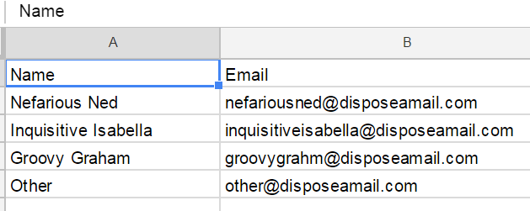

1. **Edit the List**. Names can be added or Removed.
2. You now need to update the Forms and the links so that it will use the updated information. **Press Customer Service>> and run the Update Form Steps 1 to 5**  
   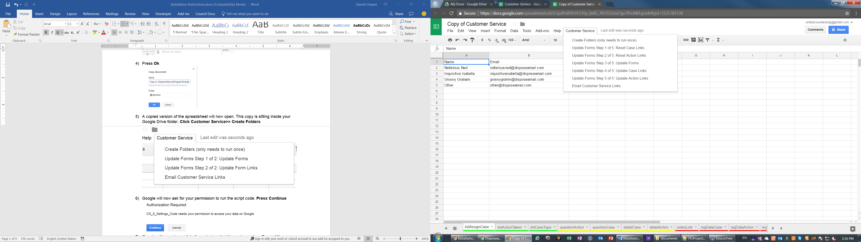
3. The Form will now show the updated values. The Website (web app) will also show the updated info in the Assigned To Drop Down.

Change the Type of Case List

The listCaseType sheet in the Customer Service spreadsheet holds the list of case types.

1. **Open the listCaseType Sheet**

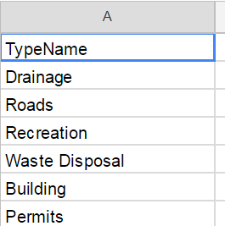

1. **Edit the List**. Names can be added or Removed.
2. You now need to update the Forms and the links so that it will use the updated information. **Press Customer Service>> and run the Update Form Steps 1 to 5**  
   
3. The Form will now show the updated values.

Change the Action Taken List

The listActionTaken sheet in the Customer Service spreadsheet holds the list of case types.

1. **Open the listActionTaken Sheet**

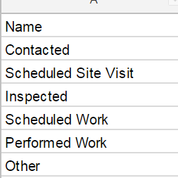

1. **Edit the List**. Names can be added or Removed.
2. You now need to update the Forms and the links so that it will use the updated information. **Press Customer Service>> and run the Update Form Steps 1 to 5**  
   
3. The Form will now show the updated values.

Change the Questions on the Case or Action Form

The form questions are generated by the code based on the questionCase and questionAction sheets. The process step below show how to edit the Case Form. The process is the same for editing the Action Form.

1. Open the questionCase sheet in the Customer Service spreadsheet

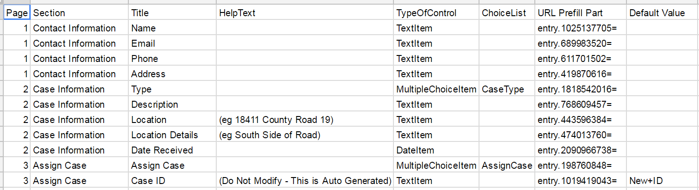

1. Edit, Add or remove rows to modify the form questions. Here is a description of what each column is for:
   1. Page – this shows which page the question will be on.
   2. Section - This shows which section the question will be in.
   3. Title – This is the question’s text
   4. HelpText – this is extra info that can be displayed for a question
   5. Type of Control – this is the type of question
      1. There are only three types available: TextItem, DateItem, and MultipleChoiceItem
   6. ChoiceList – MultipleChocieItem questions need a choice list. The choice list column holds the name of the sheet where the choices are stored. See the How To Add A New Multiple Choice Question for more info.
   7. URL Prefill Part – this will be automatically filled in by the program. You do not need to do anything with it
   8. Default Value – this is the default value that will show up for the question. Default values are only available for TextItem questions.
2. You now need to update the Forms and the links so that it will use the updated information. **Press Customer Service>> and run the Update Form Steps 1 to 5**  
   
3. The Form will now show the updated values.

How To Add A New Multiple Choice Question

Multiple Choice questions require an extra sheet to be added to the spreadsheet to hold the option values. The new sheet needs to start with the letters “list”. For example if you wanted to create a list of departments you could name your sheet listDepartment

1. Open the Customer Service spreadsheet
2. Add a new Sheet and rename it listDepartment



1. Type Name in the cell A1

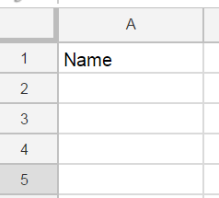

1. Type your list of options in column A under Name

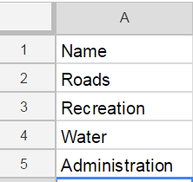

1. **Open the questionCase sheet and add a new row below the type question**

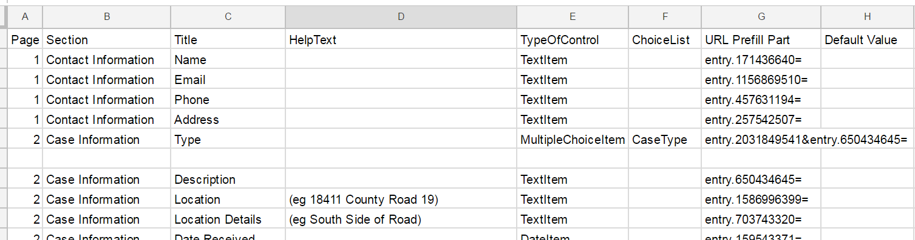

1. **Fill in the required information. Put MultilpleChoiceItem for the TypeOfControl column and Department in the ChoiceList column.**



1. You now need to update the Forms and the links so that it will use the updated information. **Press Customer Service>> and run the Update Form Steps 1 to 5**  
   
2. The Form will now show the updated values.